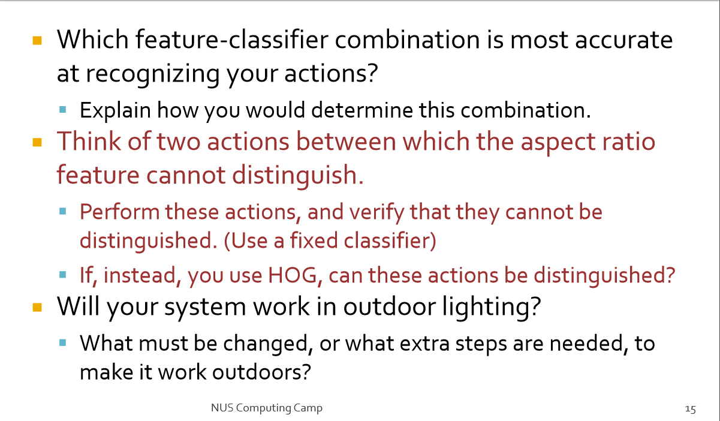

1. HOG & [Neural](javascript:void(0);) [Network](javascript:void(0);) is most accurate.

Because HOG is a good feature to describe action of people, and Neural Network not only classify, but also can learn features well.

1. Hand waving & Head up and down cannot be distinguished.

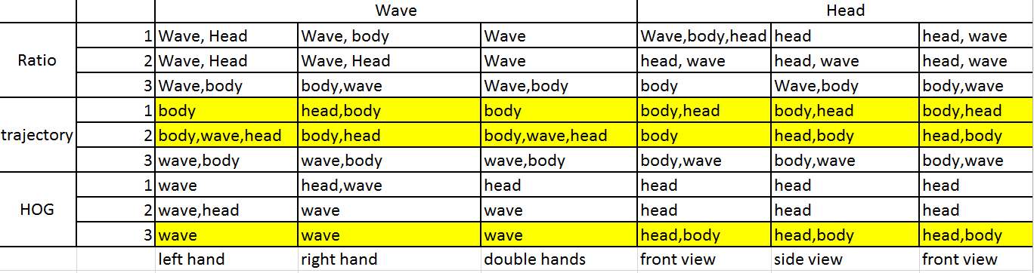

1. Wont

Need to normalization.